

Skills to Unleash:
New European Entrepreneurs

UNITEE Expert Roundtable Series
European Parliament, 26th November 2013

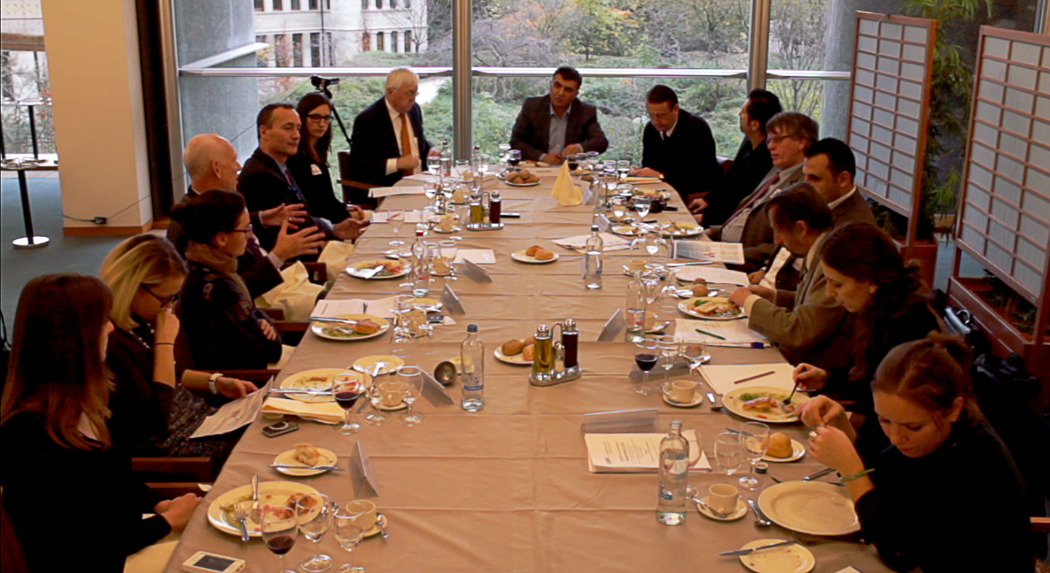

UNITEE represents, at the European level, entrepreneurs and business professionals with a migrant background (New Europeans). In that respect, one of UNITEE’s main goals is to bring the central asset its members possess to light, namely a dual linguistic and cultural background. The added-value of New European entrepreneurs can facilitate economic growth and can help Europe tackling some of its most severe problems.
Dr Paul Rübig MEP and UNITEE expressed the wish to host an event that would highlight the positive contribution of New European entrepreneurs and SMEs. They are EU’s economic backbone but also a unique window of opportunity for migrants.

On Tuesday, 26th November 2013, UNITEE, the European-Turkish Business Confederation, together with its host Dr Paul Rübig MEP, organised Skills to Unleash: New European Entrepreneurs, an expert roundtable uniting multiple stakeholders for an in depth discussion about the benefits of New European entrepreneurship.

SPEAKERS

Moderator: Dr Adem Kumcu, President of UNITEE

Paul Rübig, MEP, Group of the European People’s Party in the European Parliament
Jürgen Creutzmann, MEP, Group of the Alliance of Liberals and Democrats for Europe in the European Parliament
Verena Martelanz, Deputy Director of the EU representation of the Austrian Economic Chambers
Patrick A. Taran, President at Global Migration Policy Associates
Stephan Raes, Head Economic Department on the Permanent Representation of the Netherlands to the EU
Robert C. Kloosterman, Professor of Economic Geography and Planning at the Centre for Urban Studies, GPID, University of Amsterdam
Koos van Elk, International Researcher and consultant at Panteia BV
Gökhan Meric, WUV staff
Erkan Bülbül, Self-employed, IT-Services
Ann Kristin Mainka, BUV, Personal Assistant to the General Secretary and Project Coordinator

Dr Adem Kumcu, President of UNITEE, opened the roundtable by outlining the course of action for the 1,5h long discussion. The event should be based on answering five key question:

- How can we foster entrepreneurship in Europe?
- How can we encourage more innovation?
- How can we ensure a high level of skilled labour for our economy?
- How can we increase the degree of internationalisation among our SMEs?
- How can we create an even more open and inclusive society?

ENTREPRENEURSHIP
Dr Paul Rübig MEP, started off by highlighting that today the key barriers for European SMEs and entrepreneurship are red tape and bureaucracy.
He explained that especially in the context of SMEs, the burden of red tape and bureaucracy is created at a local level, from local policy making. Therefore, the job in Brussels consists of ensuring legislation is harmonised or the principle of mutual recognition is applied, so that SMEs can function.
Mr Creutzmann stated that it is important to create general policies for entrepreneurship, internationalisation and SMEs. He introduced COSME, an EU programme for the Competitiveness of SMEs, running from 2014 to 2020 with a planned budget of €2.3bn. It aims at providing better access to finances and markets, and at establishing better conditions for business creation and growth, addressing especially the cutting back of red tape.
The MEP also pointed out that there is a need to focus on providing equity, venture capital and market finances for New European entrepreneurs, so that they can realise their ambitions of becoming self-employed.
Mr Kloosterman confirmed the view that there is no need for specific policies. He warned of the dangers of addressing the issues from the social policy perspective, and underscored that the economic dimensions need to be the priority.
Therefore, concerning legislation, Dr Rübig pointed out that policies need to be precise and taxation schemes should take into consideration the special needs of SMEs.

SKILLED LABOUR FOR THE EUROPEAN ECONOMY
Mr Creutzmann shared the interesting fact that there are 23 million SMEs in Europe, while at the same time, we have 23 million unemployed people. If every SME could create just one job the unemployment problem would be solved.
Also, in the coming years, the demographic crisis will aggravate the problem of skilled labour shortage across Europe. By 2050, a striking 60 million people will be missed as well trained workforce for the European economy. New Europeans can be part of the solution and provide urgently needed human capital.
On that note, Dr Rübig mentioned the importance of education and training. Lifelong learning is not just a buzzword, but a serious concept that needs to be explored further when wanting to increase entrepreneurship and self-employment.

Mr Taran strongly reaffirmed the precarious situation Europe is in. Already by 2020, Europe will experience a skilled labour shortage of 40million people. Immigration is at the core of the answer to this subject of upmost importance. The paradox of the current high rate of unemployment can only be solved through improved education that transmits business know-how, and fixes the predominant skill mismatch in the European economy, so that Europe use all of its talents.
Mr Creutzmann highlighted that taking into consideration the decline in skilled labour in Germany, migrants will be needed not only to fill the skilled labour shortage but also for business succession, and to ease the acute problem of an aging workforce.

AN OPEN AND INCLUSIVE SOCIETY
Mr Raes believes that Europe’s openness to diverse talents is crucial when wanting to remain competitive. Diverse talents possess a diverse skillset that is a great asset on the global market. When being given the opportunity of self-fulfilment and the perspective of an independent and prosperous life, the chances to attract and keep foreign human capital are considerably higher.
On this note Mr Kloosterman added that today, the character of New European Entrepreneurs has changed significantly. Due to improved education and great networks, they represent a real added-value for the society.
Furthermore it is proven that ethnic, sectorial and market diversity has measurable positive effects on the economy.
In order to increase this diversity it is of upmost importance to include and make better use of the educational system. Only an education that allows for different talents to prosper and that gives all people, no matter what background, the opportunity to excel, will produce a high class workforce. On this matter there is still room for improvement and a change in the opportunity structures seems necessary.
Mr Kloosterman also pointed out that the differences between New Europeans and “native” entrepreneurs are becoming less. However the differences in between New Europeans are even more dramatic. One has to make the distinction between economic migration, consisting of job seekers, people that are trying to improve their difficult economic situation and those who flee a country for political reasons e.g. political persecutions, political migration. The second group is more likely to be highly educated and well trained.

INTERNATIONALISATION
New Europeans themselves can play an important part in bonding and bridging from their home country to their new country of residence. An invaluable asset especially in the context of internationalisation.
Mr Creutzmann strongly believes that New Europeans are extremely important when wanting to profit more efficiently from multicultural assets and transnational network. As they possess the multilingual and cultural skills that are essential for this. Their access to foreign cultures and markets can be the key for a better cooperation between New Europeans and the native entrepreneurs.
Ms Martelanz pointed to the importance of networking and mentoring programmes, and in this respect, the role of civil society such as chamber of commerce, in order to bring entrepreneurs together and facilitate internationalisation.
Ms Mainka from the BUV gave some first-hand experience on how they conducted match making and provided internationalisation opportunities for their members, at their latest Renewable Turkish-German Energy Forum.

INNOVATION
Answering the question if more research was be needed, Dr Rübig suggested more comparative studies should be done. Despite OECD research a European study, taking into consideration both qualitative and quantitative research is missing. Such study should focus specifically on how New Europeans influence the internationalisation performance of SMEs, and their added value in regard to innovation.
Dr Kumcu pointed out that the entrepreneurs represented by UNITEE are now active in more than 150 different economic sectors and 36 percent of New Europeans actually possess a degree in higher education. Their dual linguistic and cultural background is the key to more innovation and a progressive and fresh approach to traditional business practices.

In conclusion, the event was a great success, answering the key questions on how to unleash the potential of New European entrepreneurs. In the debate it became obvious that there is need for more research, in order to create evidence based policies that allows for a growth in European entrepreneurship. This roundtable was a right step into the direction of a sustainable multi stakeholder dialogue on the issues of New European entrepreneurship. It has been highlighted that New Europeans, with their unique skillset, as well as a diverse workforce in general, are very beneficial and get assets for both internationalisation and innovation. UNITEE will remain a key player in bridging and bounding between cultures and stakeholders, for a better future in Europe!

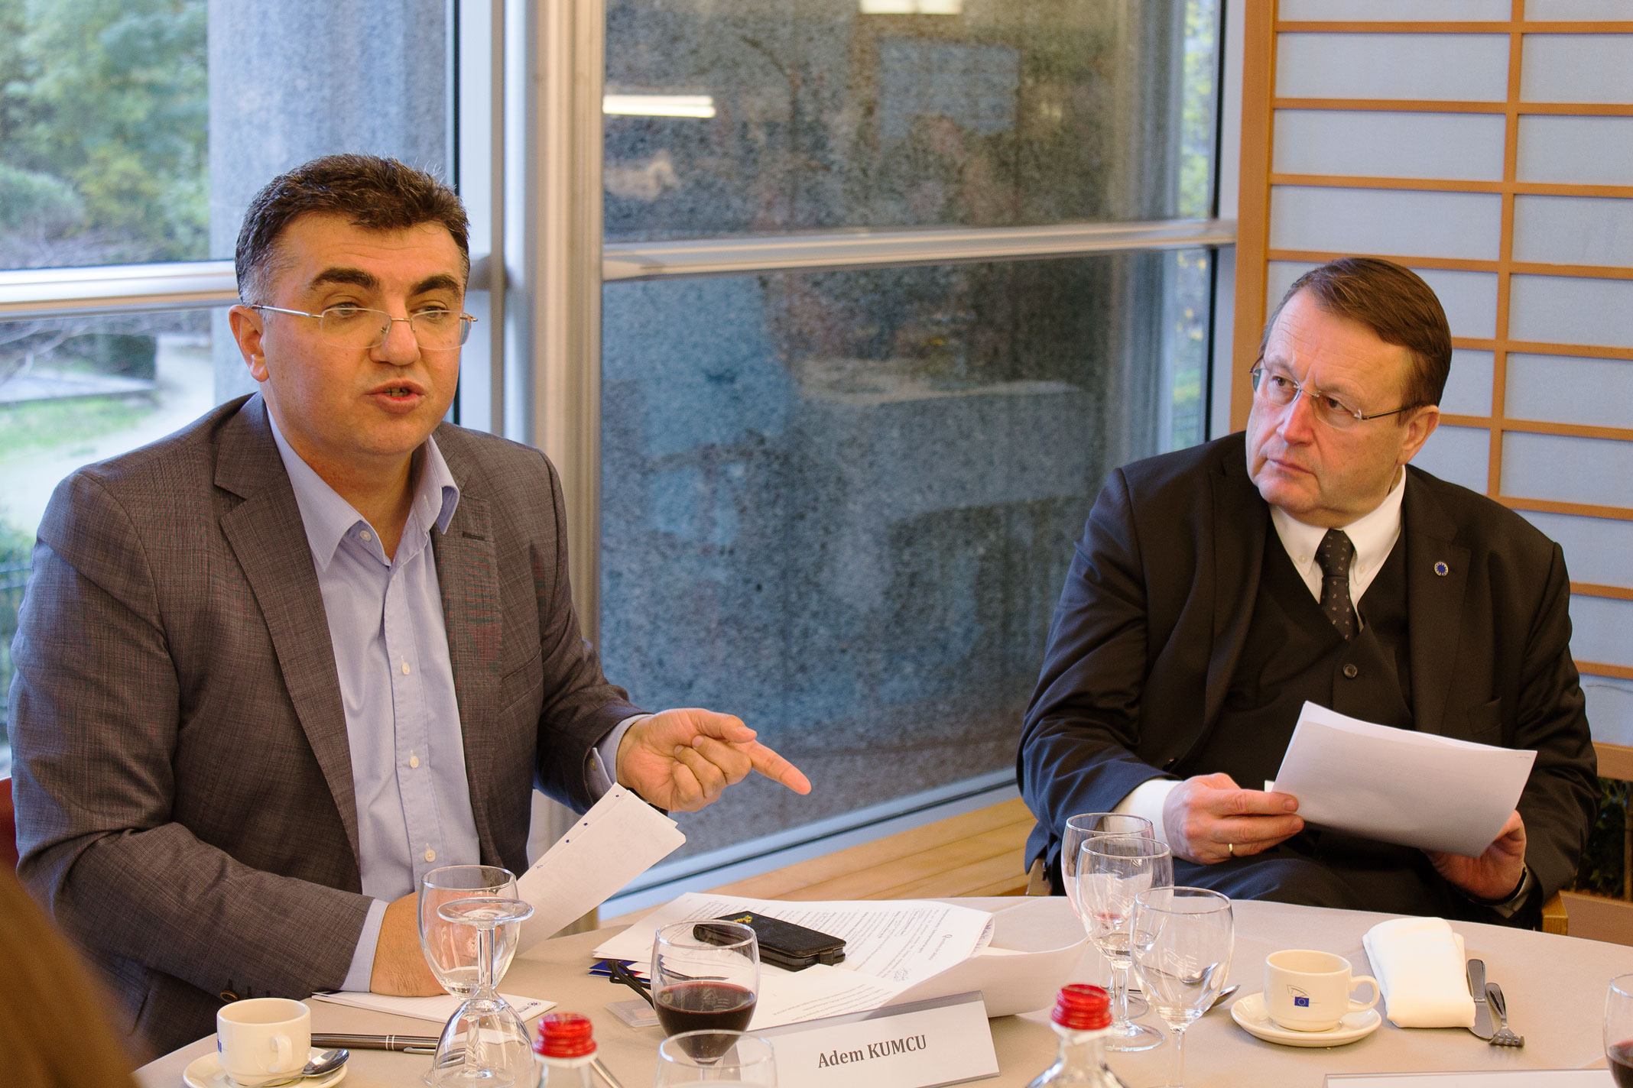

The UNITEE Team wish to thank all the participants
for their valuable contribution to this event!

UNITEE

Address: Meeûssquare 23
1000 Brussels, Belgium

Phone: 0032 2 204 05 33
Fax: 0032 2 218 67 24
E-mail: info@unitee.eu

PRESS & FURTHER INFORMATION
Mareike TRULL
Public Relations Manager
Phone (office): +32 (0) 2 204 05 33
Email: mtrull@unitee.eu

www.unitee.eu
http://blog.unitee.eu

